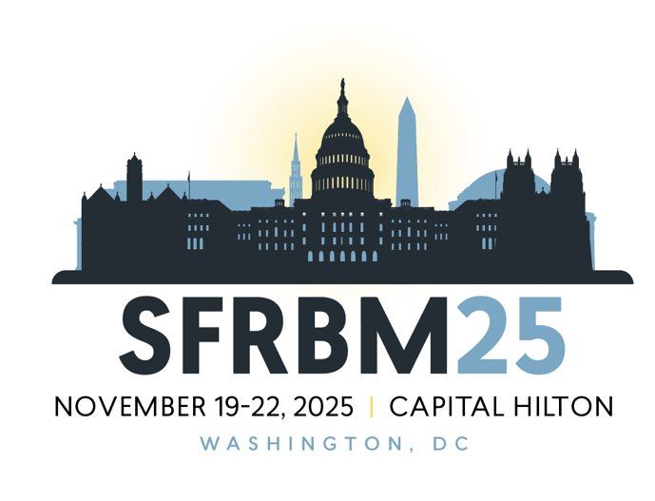  
  
**SYMPOSIUM PROPOSALS**

SfRBM 2025 will feature 12 thematic symposia consisting of two invited senior speakers (30 min segments – 25 min presentation / 5 min Q&A) and 2-3 junior speakers selected from submitted abstracts (20 min segments – 15 min presentation / 5 min Q&A)

**Instructions:** Please complete the form below, providing requested details for the symposium you are proposing – including a summary, names of chairs, presentation titles and contact information for two (2) senior speakers. We do allow proposal submitters to be one of the senior speakers.

**Questions?** Please contact SfRBM Staff at (317) 205-9482 or via [info@sfrbm.org](mailto:info@sfrbm.org).

**Ready to send your proposal?** Completed proposals should be sent to Susanna Beier, SfRBM’s Meeting Manager, at [sbeier@hollandparlette.com](mailto:sbeier@hollandparlette.com) by March 3, 2025.

**Disease Sectors**: Cancer, Cardiovascular and Pulmonary, Metabolism/Bioenergetics, Neurodegenerative Disease, Redox Regulation and Mechanisms, Interdisciplinary

We look forward to receiving your proposals!

**Carola Neumann, MD**

University of Pittsburgh

SfRBM 2025 Conference Program Chair

**SfRBM 2025 SYMPOSIUM PROPOSAL FORM**

**SYMPOSIUM TITLE:**

**DISEASE SECTOR:** *Must be completed / select from the list on page 1*

**PROPOSER (Name / Institution / Email):**

**SYMPOSIUM SUMMARY** (Maximum 300 words)

**SYMPOSIUM CHAIRS**

**Chair 1 Name / Degree(s):  
Institution:**

**Department/Division:**

**Address:**

**Country:**

**E-mail:**

**Chair 2 Name / Degree(s):  
Institution:**

**Department/Division:**

**Address:**

**Country:**

**E-mail:**

**SYMPOSIUM SPEAKERS**

**Presentation Title 1:   
Speaker 1 Name / Degree(s):  
Institution:**

**Department/Division:**

**Address:**

**Country:**

**E-mail:**

**URLs:**

**SPEAKER 1 Abbreviated CV (maximum 300 words)**

**SPEAKER 1 Publications (maximum 10)**

**Presentation Title 2:   
Speaker 2 Name / Degree(s):  
Institution:**

**Department/Division:**

**Address:**

**Country:**

**E-mail:**

**URLs:**

**SPEAKER 2 Abbreviated CV (maximum 300 words)**

**SPEAKER 2 Publications (maximum 10)**

**ALTERNATE SPEAKER**

**Presentation Title Alternate:   
Alternate Speaker Name / Degree(s):  
Institution:**

**Department/Division:**

**Address:**

**Country:**

**E-mail:**

**URLs:**

**ALTERNATE SPEAKER Abbreviated CV (maximum 300 words)**

**ALTERNATE SPEAKER Publications (maximum 10)**